PROGRAMED INSTRUCTED TEXT ON THE USAGE OF
ON IN AT

Spring, 1971
Fatma Özden Ekmekci

Page 1

In this program, we are going to examine the use of the three prepositions: in, at, on.

These prepositions can be studied in relation with different classes of words:
- Verb+prep.: e,g. He turned in. his paper today.
- Adjective+prep.: e.g;. He is interested in books.
- Prep. + nouns or pronouns. e.g. I saw him at school today,

Which use of these prepositions do you want to go over?
Verb + prep. Turn to page 101. (To be prepared.)
Adjective + prep. Turn to page 201. (To be prepared.)
Prep. + Noun Turn to page 12. Tap on the button to go to page 12.

Page 2 ( from page 26)

If you are coming from page 1, this is not the right page. If you are on the wrong page turn to page 1.

Your answer: He wrote the words on his notebook.

No, it is not right because he wrote inside his notebook. When we say, “on his notebook”, we mean “on the cover of his notebook". Here, the use of prepositions is determined by the meaning we want to give.
However, we do not write “on our notebook" but we write "on a paper". As you see here, the use of different nouns determines the use of the preposition.

Now turn to page 26 and choose the right preposition, after examining the noun that comes before the preposition and the picture concerning the sentence.
Page 3 (from page 9}

Your answer: “On” is used incorrectly in this sentence:
"The picture is hanging on the wall."

No. This use of “on” in this sentence is correct, because it
suggests that the picture is hanging on the surface
of the wall where we can all see it.

Turn to page 9 and try to find the incorrect sentence.

Page 4 (from page 52)

Your answer: They are riding in a big boat.

No. It is not right. The boat is big so we cannot use “in”.

Try the other alternative, on page 52,

Page 5 (from page 42)
Your answer: Cats like to sit on the roof.

Yes. You are right. Since we see the cat sitting on the surface of the roof,
we can only use on.

Now let's find out the right preposition for this sentence:
There is a garden –––– the back of the house.
at: (turn to pg. 26)
on: (turn to pg. 8)
in: (turn to page 40)
Page 6 (from page 26)

Your answer: He wrote the words in his notebook.

Good! You’re correct. You know that you write “on a page" or at the top of a page” but since the pages are in the notebook, you write "in a notebook. You treat newspapers the same way.
e.g:
I read it in the newspaper.
It was on the first page of the newspaper.

Which preposition would you use if "you write —- a blackboard”?
in (turn to pg. 56)
on (turn to pg. 9)
at (turn to pg. 38)

Page 7 (from page 37)

Your answer: Let’s meet in the theater tomorrow.

In this particular conversation it is incorrect because if the second speaker were informed that they would meet in the theater, he would not ask the question "inside or outside?”

Now turn to page 37 and. choose the alternative answer.

Page 8 (from page 5)

Your answer: There is a garden on the back of the house.

No. You are getting tired I think. I can not see a way of putting a garden on the back of a house. If you say, "Some mothers carry their children on their back.” that would be perfectly correct, but not the house.

Now turn to page 5 and try to choose the correct form.

Page 9 (from page 6)

Your answer: You write on a blackboard.

Correct. A blackboard has a flat surface to write on. Now we know that on has the meaning of lying, covering or hanging from the surface of another object. On is used. with objects that have two dimensions, length and width.

According to this definition in which sentence the preposition on is used incorrectly?
His picture is hanging on the wall. (turn to pg. 3)

There is a black mark on the ceiling. (turn to pg.15)

She has white shoes on: her feet. (turn to pg.22)

She wears a ring on her finger. (turn to pg 46)

She hit the ball on the hole. (turn to pg.52)

Page 10 (from page 42)

Your answer: cats like to sit in the roof.

No. As the picture suggests the roof is a flat surface covering the top of the house. There is no way of getting on the roof. A roof is just the upper surface of the house. Cats may sit under the roof' in case of rain or sunshine.

Turn to page 42 and make an appropriate choice.

Page 11 (from page 28)

Your answer: She lives on Istanbul.

No. Istanbul is a big city. We live on the street.

Cities are bounded politically. From one city we move into another one.

Turn to page 28 and make the right choice.

Page 12 (from page 1)

Your answer: I want to go over the use of prepositions in, on, at together with nouns.

In prepositional noun phrases, the use of prepositions is determined by two factors.
- The choice of preposition may depend on the noun following the preposition.
For example:

I saw him in the classroom today.
If we want to use "campus" instead of "classroom", we have to change. the preposition in to on. The result would be "I saw him on the campus today".

- The prepositions are selected depending on what is desired to be expressed.

In the first picture below, the pencil is on the book.
In the second picture, the pencil is in the book.

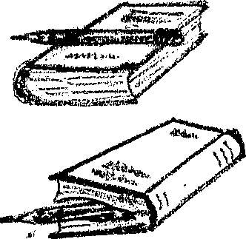

How is the preposition determined in this sentence?
He is sitting at the table.

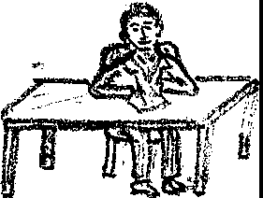

If your answer is:
- “It is determined by the noun”, turn to page 18.
- “It is determined by the intention of the reader”, turn to page 25.
Page 13 (from page 23)

Your answer: They stay in 2l Zeren Street.

No, it's incorrect. When the number and the name of the street is given we cannot use in. The nµmber of the house suggests a definite point on a specific line. —x—— (Zeren Street)
21

In is used when we see children playing.
e. g. It is dangerous for children to play in the street.

On is acceptable in American English in this particular sentence

Now1 turn to page 23 and try to make the right choice.
Page 14 (from page 19)

Your answer: He is not at home now. He is in work.

No, it ^{I}s not quite right. "He is in work" means he has a job. If you say
“ He is in work.", you have to make some changes in the first part of the sentence in order to make it clear.

e.g. He does not stay at home any longer. He is in work.

Turn to page 19 and choose the other alternative, after examining the given examples.
Page 15 (from page 9)

Your answer: "On” is used incorrectly in this sentence.
"There is a black mark on the ceiling.

I wonder why you think so because this is a completely correct sentence.
The black mark is seen on the surface of the ceiling.

Turn to page 9 and. try to find the incorrect sentence.

Page 16 (from page 24)
Your. answer: The children are playing on the grass.

Yes, you're right. They play on the surface of the grass. The word “grass” belongs to the same group of words as “on the lawn.", "on the ground”, “on the floor”. Instead of “grass” if words like “yard”,”garden”, ''field",”room”, ''house" were placed, we would use in because these words suggest places that are. somewhat covered. by some kind of a boundary. With words like “light”, “dark”, “rain”, “sun” and “shade" it is used as well because we are surrounded by them during their existence.
e,.g. I like walking in the rain.

Fill in the blank in this sentence.

They hid the shadows.

If your answer is:
on, turn to page 21.
at, turn to page 49.
in, turn to page 36

Page 17 (from page 23)

Your answer: They stay on 21 Zeren Street.

No, you’re not right. The number of the house is given. This means that we're mentioning a definite point on Zeren street.

Now turn to page 23 and make the right choice.
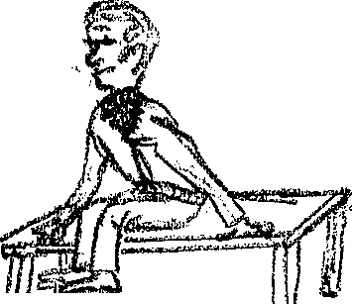
Page 18 (from page 12)
Your answer: The use of preposition on is determined by the noun in this
sentence.
No. We can say, “ He is sitting on the table.”

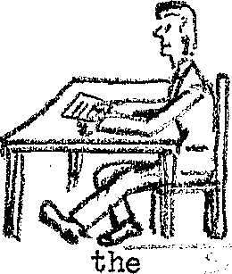
or
“He is sitting at the table.

Turn to page 12 and try to choose the correct answer.

Page 19 (from page 37)

Your answer: Let's meet at the theater tomorrow·.

Yes, you're right. If this sentence were given alone, you could also think of the possibility of using in. In this case, however, you do not because through the conversation, you find out the notion of inside is not given in the first sentence.

As you see, in this sentence the use of in or at is determined by the intention of the speaker. There are several other examples of this kind.
e.g.
- A. She is in the play. (She is taking part in the play.)
B. She is at the play. (She is watching the play.)

- A. She is in school. (She is a student.)
B. Her mother is at school this morning, you can see her there.
(She went to school but sen is not necessarily a student.

Which preposition do you think is more suitable?

He is not at home now, he is —— work.
If your answer is at, turn to page 50.
If your answer is in, turn to page 14.

Page 21 (form page 16)

Your answer: They hid on the shadows.

No. On, as you remember, has the meaning of being on the surface.

In this sentence, however, it suggests. that the shadows surround them and help them not to be seen easily.

Turn to page 16 and try to find out the right answer.

Page 22 (from page 9)

Your answer: "On." is used incorrectly in this sentence•:: "She has white shoes on her feet."
No, “on” is used correctly in this sentence. It suggests that the shoes are covering the surface of her feet.

Turn to page 9 and find out the incorrect sentence.

Page 23 (from page 28)

Your answer: She lives in Istanbul.

Yes, it is correct. Since Istanbul is a big city, we use in. However, remember that here the noun as well as the verb determine the use of the preposition. If the verb were ”went” you would use the preposition to because the verb “go” indicates motion not location.

Let’s try this one.

They stay — 21 Zeren Street.

If your answer is on, turn to page 17.

If your answer is in, turn to page 13.
If your answer is at, turn to page 37.
Page 24 (from page 50)

You’re right if you have filled the blanks in the following way:
- The woman. is at the door. (In the picture she is standing· near the door, outside the house.)
- The child is in the house. (He is inside the house.)
- The bird is on the root, (The bird is touching the surface of the.roof..)

Since in suggests the inside of something, we say "in the garden", "in the yard", "in the field" because we always think of people, or children playing, sitting or working inside these places. However, when we say “park”, we can use both in or at according to what we mean. Remember the examples we had with “theater” (pg.19), “station” and “office” (pg.37).

If a person tells you to meet him ”at the park”, he either suggests the place you usually meet in the park, or if there is no specific point you meet at that park, he probably means at the front of the park. If you want to make sure, you can ask for a specific place.
Now fill in the blank in this sentence.
The children are playing —— the grass.
If your answer is in, turn to page 51.
If your answer is on, turn to page 61.
If your answer is at, turn to page 30.

Page 25 (from page 12)

Your answer: The use of preposition on is determined by the intention of the reader.
Yes, you’re right because using different prepositions with the same noun would give different meanings.
e.g.
- He is sitting at the desk. (He is sitting on the chair and using the desk to study at.)
- He is sitting on the desk. (He is sitting on the surface of the desk.)
- He keeps his papers in his desk, (His papers, are inside his desk.)

We use in, on, at under certain conditions to express the place or the time of an action.

Read this sentence, “She is in the house.”.

If you say “ in is used to express time”, turn to page 29.
If you say, “in is used to express place”, turn to page 42.

Page 26 (from page 5)

Your answer: There is a garden at the back of the house.

Yes, it is correct. The use of “black” makes us think of a particular place outside the house. Instead of “garden” if we use “room”, we would say ''in the back of the house” because we know that the room is inside the house.

Examine these two sentences.
The pencil is in the box.
The pencil is at the edge of the box.

Let’s' try another example:

He wrote the words ——his notebook.

If you fill in the blank with on, turn to page 2.
If you fill in the blank with at, turn to page 33.
If you fill in the blank with in, turn to page 6.

Page 27 (from page 36)
Your answer: She was waiting on the sun.

No. While she was waiting, the sun was shining on him.

Turn to page 36 and try to choose the right answer.

Page 28 (from page 52)

Yes, you’re right. Since the boat is big, we use on. If it were a small boat we would say, "in a small boat".However, we say, "He rides on a bicycle” although it is a small vehicle. The: reason for that is that while riding, we sit on the surface of the bicycle.
We use, in, on, at: in locating the place of a building, a vehicle or a person or an animal. Let's: discuss them by using; them with verbs like “be”, “live”, and “ stay”.
The larger the area, the· more we tend to use in. The specific and the smaller the area we use at. With the· names of streets we use on. When the number of the building is given we use at.
Suppose the big circle is the world, what preposition would you use in the following sentence? She lives —— İstanbul.
on: Turn to page 11
at: Turn to page 47
in: Turn to page 23
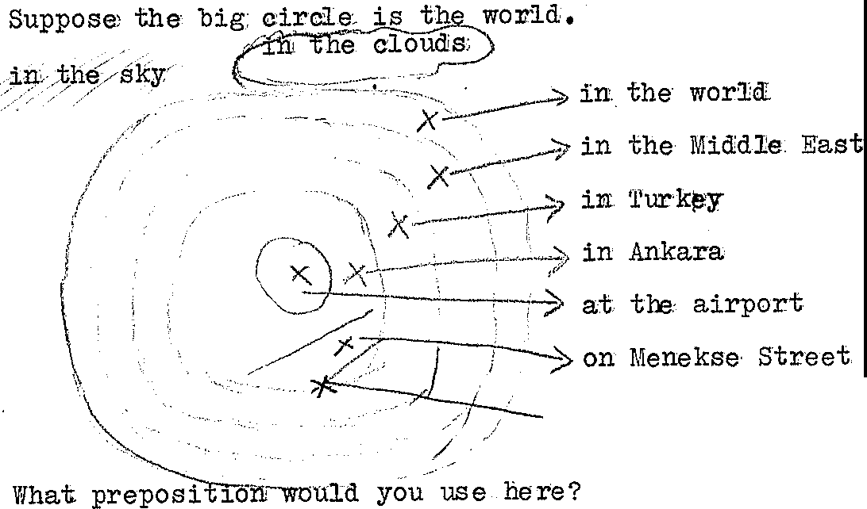

Page 29 (from page 25)

Your answer: In expresses time in this sentence: ”She is in the house.”

No. “In the house;" expresses the place she is in. It tells us where she is.

"When does John study?"
Which is the correct answer to this question?

If you choose “He studies in the library”, turn to page 39.

If you choose “He studies in the evening, turn to page 45.

Page 30 (from page 24)

Your answer: The children are playing at the grass.

No, it is not correct because the children are touching the surface of the grass with their feet or even with their hands while playing.

Now turn to page 24 and choose the right answer.

Page 31 (from page 42)

Your answer: Cats: like to sit at the roof

No, it is not right. The cats only sit on the surface of the roof. You can: use at when you give a specific point in an area.
e.g. Cats like to sit at the edge of the roof,

Now turn to page 42 and try to choose the correct answer..

Page 32 (from page 36)

Your answer: She was waiting at the sun.

No, the sun is too hot a place to “wait at”. In the future, do you. think they can find a way to send astronauts to the sun?

In this sentence however, the sun is used in the sense of sunlight.

Now turn to page 36 and make the right choice .

Page 33 (from page 26)

Your answer: He wrote the words at his notebook.

No. There is no specific place mentioned.

You can probably say “at the top of his paper" but not "at his notebook" in this particular sentence.
You write on the page of your notebook.
Where are the pages when you close your notebook ?

Now turn to page 26 and find the correct answer.

Page 34 (from page 48)

Your answer: While his parents were resting on the park, he was playing in the golf course.

No. Parents were inside the park while he was playing on a surface of a special platform made for golf players.

Turn to page 48 and try the next alternative. .

Page 35 (from page 44)

Your answer: Look at those lovely boats in the lake.

No, it is not correct. Although a small proportion of the boat is in the water, the: largest. part stays on the surface of the lake.
That's why we can see the boats clearly.

If the boats were wrecked, they might be in the lake and in that case we could not see them at a distance.

We can use in the lake when we use the verb swim. While swimming, a large portion of our body stays in the water.

Now turn to page 44 and read the sentence using the other alternative.

Page 36 (from page 16)

Your answer: They hid in the shadows.

Yes,you’re right. They are surrounded by the shadows.
Being enclosed somehow suggests the use of in,
e.g.
You sit in an armchair.
(This is because your body is somewhat enclosed on the back and on both sides.) but,
You sit on a chair.
(because you can only lean your back against the chair.)

Which preposition would you use here?
She was waiting —— the sun.

If you say in, turn to page 43.
If you say on, turn to page 27.
If you say at, turn to page 32.

Page 37 (from page 23)

Your answer: They stay at 21 Zeren Street.

Yes, you're right because the number of the house on that street is given. If
The number had not been given, you would have used "on Zeren Street”.

Although we said that at, suggests a specific place, we see it being used in situations where the exact location is not known.
When I say, "I saw him at. Dr. Esen's office.", I do not exactly say whether I saw him inside his office or in the waiting room or at the door of the apartment house. It still suggests a specific point when it is compared with this sentence, “ I saw him in Ankara". When I say, “At Dr. Esen’s office”, I am marking a point in a big city. Usually, you use at with places where you go to get that special treatment or errand done.
e.g.
You have your haircut at the barber’s. (the shop)
You buy bread at the baker's.
You buy a notebook at the stationer’s.
You buy fruit at the grocer ‘s.

By reading the whole conversation, fill in the blank.
A.Let' s meet——the theater tomorrow.
B. Inside or outside the theater?
A.Let’s wait for each other in front of the closed ticket window.
If your answer is in turn to page 7.
If your answer is at turn to page 19.

Page 38 (from page 6)

Your answer: You write at a blackboard.
No. We don't mention any particular point of a blackboard.
You can write· at the top or at the bottom of a blackboard but not “at a blackboard”. You can only stand at the blackboard.

You can use the preposition at with any noun phrase if the verb requires the use of a specific preposition.
e.g.
I am looking at the blackboard.
I am looking at this page.
Here in these sentences the nouns following the preposition do not have any function in the right choice of a preposition because the verb “'look” determines the preposition already.
We know from other examples that “write” does not force us to use at and there is no other word to suggest a specific point of the blackboard.
So let's turn to page 6 , again and try to choose the correct answer.
Page 39 (from page 29)

Your answer: "He studies in the library" is the correct answer to the question, “Where does John study?".

No. In the answer we are told the place where John studies, not the time he studies.

Turn to page 29 and choose the correct answer.

Page 40 (from page 5)

Your answer: There is a garden in the back of the house.

No, it is not right. The garden is not in the house.

Turn to page 5 and make another choice.

Page 41 ( from page 55)

Your answer: He is standing on the corner.

Yes, you're right. He is standing on the surface that is provided for people to walk on.

With, verbs of location on is also used for direction interchangeably with to when certain nouns· such as: “the right”, “the left”,”the north”, “ the south”, “the east”, “the west”, etc. are used.

Change the following using one of these prepositions:

Preparatory school is to your right as you go to the Administration building.
If you replace to with at go to page 53
If you replace to with on go to page 58.

Page 42 (from page 25)

Your answer: It expresses place in the sentence: "She is in the house."

Yes, you're right. The phrase “in the house” indicates where she is.

Three of these prepositions(in,on,at) can be used in noun phrases expressing place. Let's: investigate: how they are used.

In is used in suggesting the inside of an object that has volume, (three dimensions: length, width and height) or surrounded by some boundary.
e.g.
The pencil is in the box.
He is playing in the garden.

On is used in suggesting the surface of an object that has width and length or it suggests that the object that has volume is covered.
e.g.
The pencil is o The pensil is onthe box.
She wea She wears her ring on her small finger.

At is used in suggesting a specific point that has no dimension.
e.g.
The pencil is at the edge of the box.
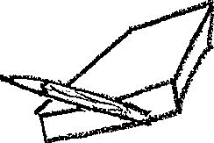

As

As you see in the first four sentences above, we used in or on.
In the last sentence however, to specify the particular point of the box, we added the word “edge.

Now fill in the blank in this sentence.
Cats like to —— the roof.

If you used at, go to page 31.
If you used in, go to page 10.
If you used on, go to page 5

Page 43 (from page 36)

Your answer: She was waiting in the sun.

Yes, you are right. With the verbs of location, we use in with nouns like “rain”,“sun”, “open”, “light”, “shade” and “shadow”.

Now let’s fill in the blank in this sentence.

The farmers were working —— the cornfield.
If you used on, go to page 57.
If you used in, go to page 48.

Page 44 (from page 48)

Your answer: While his parents were resting in the park, he was playing golf on the golf course.
Yes, you’re right. Parents are inside the park and he is playing on the surface of a special ground for golf players.
Let's; try this one
Look at those lovely boats —— the lake.

If you filled the blank with on, go to page 55.
If you filled the blank with in, go to page 35.

Page 45 (from page 29)

Your answer: ''He studies in the evening" is the correct answer for the question "When does John study?"

Yes,indeed. "In the evening" tells the time when he studies.

Now let’s complete the following sentence .

If we say, “She is in the house.”, in expresses ————.

If you completed the sentence using the word time, go to page 29.
If you completed the sentence using the word place, go to page 42.

Page 46 (from page 9)

Your answer: “On is used incorrectly in this sentence: “She wears a ring on her finger.”

No. This sentence is correct. On, here, suggests that the ring surrounds the surface of her finger.

Now turn to page 9 and try to find the incorrect sentence.

Page 47 (from page 28)

Your answer: She lives at Istanbul.
No. Istanbul is a big city surrounded by a political boundary.
We can only say, "As I was going to Europe, I stopped at Istanbul”.

Ankara——————X——-——— Europe
Istanbul

Turn to page 28 and read the instructions again and make your choice.

Page 48 (from page 43)

Your answer: The farmers were working in the cornfield.
Correct. Since they work inside the field", we us in
However, on is used for locating a place that is used mainly for a particular purpose such as sports, games, dances, instructions. etc.
e.g.
We played on the golf course.
on the tennis court.
on the football field.
on the campus.
on the dance floor.
on the playground.
You should remember the use of on only with this group of' words.
We can easily fit these words into the same category with “grass” and “lawn”. Remember we say, "They­ are playing on the grass.
The golf course,the tennis court, the football field are specially made for the players to play on. The same rule applies for the playground and the dance floor .Besides that we know· that with 'floor and 'ground' we. use on.
Now let's fill in the blank in this sentence.
While his parents were resting —— the park, he was playing golf —— the golf course.
If your answer is ….on the park………in the golf course, go to page 34.
If your answer is….. in the park………on the golf course, go to page 44.

Page 49 (from page 16)

Your answer: They hid at the shadows.

No. They can hid some place where they can be covered so that they are not seen easily,

Go back to page 16 and make another choice,

Page 50 (from page 19)
Your answer: He is not at home now, he is at work.

Yes, you’re right. Usually, when at is used together with the name of a place, it suggests the existence of a person or an object at that particular place. If we wanted to imply that he has a job, we would say, "He is in work”.

In general we can say that if there is no reason for saying in or on . That is if the person or the object is not really inside a place or touching the surface of an object, we use at.
We say, “ The key is in the door.”, when half of the key is inside the door . In other words, the key is inside the keyhole.
On the other hand, we say, “The sign is put on the door.” because the sign is attached to the surface of the door. In other words, the sign is on the door.
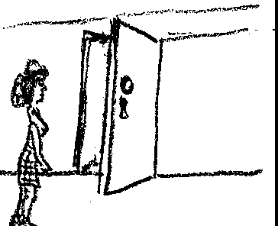

If a person is standing somewhere very close to the door, we say, “She is standing at the door”. Here we want to indicate the specific point in that room or that building she is standing at.
By looking at the picture below, fill in the blanks. Use each preposition once.
The woman is—— the door.
The child is —— the house.
There is nothing —— the roof.
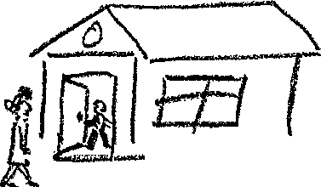

Turn to page 24 to check your answers

Page 51 (from page 24)

Your answer: The children are playing in the grass.

No. It is incorrect unless the height of the grass is more than the height of the children so that they are almost covered by grass. I am sure you did not think of this possibility when you gave this answer.

Now turn to page 24 and choose the answer which is more reasonable.

Page 52 (from page 9)

Your answer: “On” is used incorrectly in this sentence:
"She hit the ball on the hole.
Yes, you're right, A hole is like the inside of a box where there is enough space to keep the ball in. A hole does not have a flat surface to keep the ball on it.
In relation to transportations, in or on is used depending on the size of the vehicle . If the vehicle is small in is used.
e..g. The girls are in the car.
If the vehicle is large on is used.
e.g. They went on the bus.
However, if the bus is not moving and there are some people in the vehicle, we say, “They are waiting in the bus.”

Which preposition do you use in this sentence?

They are riding —— a big boat.

If you use on, turn to page 28.
If you use in, turn to page 4.

Page 53 (from page 41)

Your answer: The Preparatory school is at the right as you go to the administration building.

No, it is incorrect. The equivalent of to in relation to showing direction is not at.

Turn to page 41 and choose another alternative.

Page 54 (from page 58)

Your answer:
- There is fruit on top of the refrigerator.
- There is ice in the refrigerator.

Yes, you're right, The first is not in the refrigerator but it is on the outer top surface of the refrigerator, Ice, on the other hand, is in the upper part of the refrigerator.
If we want to mention, the presence of an object in any part of closed place containing volume, we can use­ in.
e.g. “in the front of it” or “in the back of it”

However, if the object touches the inner surface of the­ closed place,(e.g. walls, ceiling, flour) we use on.
e..g, Ahmet. is sitting in the back of the room.,
There is a fly on the ceiling.

Now you try to fill in the blank with an appropriate preposition.

In order to see the blackboard better, he sits —— the front of the room.
If you use in, turn to page 66.
If you use on turn to page 60.

Page 55 (from page 44)

Your answer: Look at those lovely boats on the lake.

Yes, you 're right. Since we see the boats on the surface of the lake we use on.However ,when a person swims, most of his body stays in the water. Therefore we say, "He is swimming in the lake."

Here the choice of preposition is restricted by the verb. We also saw instances where the noun used after the use of that preposition such as “on the: dance floor”, “in the field”.
Think of a cross section of two roads. There are four corners.
On each corner there are four buildings. On both sides of the two roads, which are named Ata Street and Umut Street, there are pavements.

We say, the building is at the corner of ATA Street and Umut Street.

If a person is standing on the pavement, we say, he is standing on the corner because pavements are made for people to stand or walk on.

If a person is standing on the street but very close to the corner, we say, he is standing at the corner.
In this picture where is the man standing?
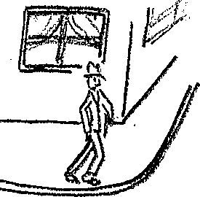

If your answer is on the corner, turn to page 41.
If your answer is in the corner, turn to page 59.

Page 56 (from page 6)

Your answer: You write: in a blackboard.

No, it is not right. Blackboard is a flat surface like a page of a notebook but not like a notebook because there is no way of opening the blackboard so that the written words could be written inside the blackboard.

Now, turn to page 6 and make your right choice.

Page 57 (from page 43)

Your answer: The farmers were working on the cormfield.

No. The farmers were working inside the cornfield.
Cornfield is a place like a garden, a yard, or a field, which is surrounded by some boundary.

Turn to page 43 to choose the right alternative.

Page 58 (from page 41)

Your answer: The Preparatory School is on your right as you go to the Administration Building.
Yes, you're correct. We can use either on or to for direction in a sentence where a verb of location is used,
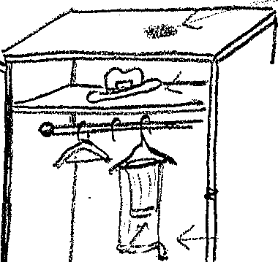
Now let's discuss the use of in, on, at with certain expressions followed by a noun Let's: first see some different possibilities with ‘closet’

There is a hat in the closet.
There is nothing on the side of the closet.
There is plenty of room in the middle of the closet.
We do not see the shoes at the bottom. of the closet.

Now. looking at the second picture fill in the blanks
either with in or on.

r

If your answer is on for 1 and in for 2, turn to page 54.
If your answer is in for 1 and on for 2, turn to page 61
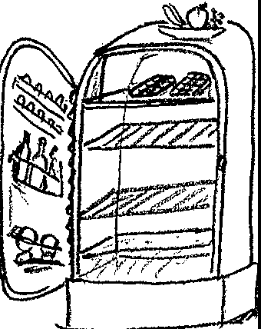

There is fruit —— the top of the refrigerator.

There is ice —— the top of the refrigerator.

Page 59 (from page 55)

Your answer: He is standing in the corner.

No, it is not correct. Remember that he is not in the­ building. If he were waiting inside the building, which is at the corner of ATA and Umut streets, we would say, “He is standing in the corner.”

Now turn to page 55 and make the right choice.

Page 60 (from page 54)

Your answer: In order to see the blackboard better, he sits
on the front of the room.

Wrong. Remember he is inside the room

Go back to page 54 and choose the other alternative.

Page 61 (from page 58)

Your answer:
- There is fruit in the top the refrigerator.
- There is ice on the refrigerator.

Wrong: The fruit is not in the refrigerator, and the ice is not on the refrigerator.

Go back to page 58 and choose the other alternative.
Page 62 (from page 66)

Your answer: He is standing in the front of the theater.

No. As you see in the picture on page 66, the man is not inside.

Turn to page 66 and try to choose the correct preposition.

Page 63 (from page 68)

- This is a classroom, The students are sitting at their desks. (12, 18, 25)
- The teacher is standing in front of the class, (73)
- There is a blackboard on the wall, (9, 38)
- He has: written some sentences on the. blackboard. (6, 9, 56, 38)
- The students have copied these sentences in their notebooks. (6, 33, 2)
- There is a big desk (in or at) the front of the room. (66,62,)
- There is a paper basket in the corner. (55, 41, 59)
- There is a window on the right side of the room. (58)
- At the window, there stands a bird. (50, 24)
- There is a small bookshelf in the back of the room.(68)

If you have a different answer in your paper, turn to the given pages for each sentence.

Now turn to page 78.
Page 64 (fom page 78)

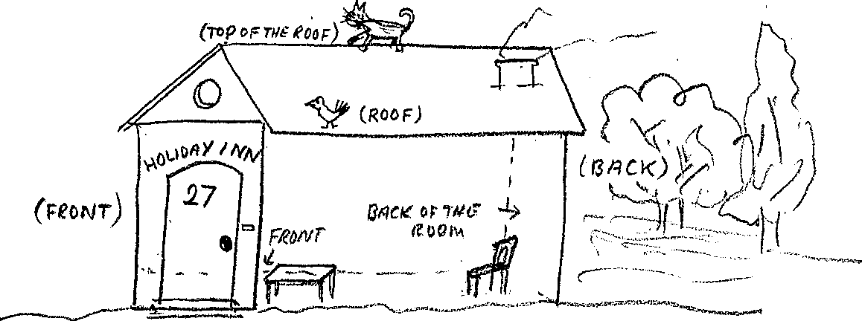

Using in,on,at, complete the following by looking at the picture.
- The cat is —––––––––––———————————–.
- The bird is —————————————————-.
- The chair is —————————————————-.
- The table is —————————————————.
- There is a big garden ——————————————.
- The number is put ——————————————-.
- —————————————, it says “Holiday Inn”.

Turn to page 75 and check your answers.

Page 65 (from page 75)

The verb “arrive” is not used with the prepositions to in English as it is used in Turkish. However, it is used with in, on or at, depending on the noun following these prepositions.
The rules for the use of these prepositions with “arrive” are the same as the rules that indicate the use of in, on, at, with verbs of location.
e.g.
He is at the airport.
He arrived at the airport.
He stays on the campus.
He arrived on the campus.
He lives in New York.
He arrived in New York at 6 o'clock.

Now let’s try this sentence.

He arrived ——Istanbul yesterday.

If your answer is at, turn to page 69.
If your answer is on, turn to page 71.
If your answer is in, turn to page 80.
Page 66 (from page 54)

Your answer: In order to see the blackboard better, he sits in the front of the room,

Yes, you're right. Since we know that he is inside the room, we can use in.
The use of the article “the” before “front” is very critical here. If we omit the article, the meaning of the sentence changes. When we look at the picture including a house, we say:
e.g. There are flowers in front of the house. His bedroom is in the front of the house.
As you see the use of the article or omitting the article is sentence changes. By looking at the second picture, fill in the blanks to answer the question:, “ Where is the man standing?”
He is standing —— —— front of the theater.

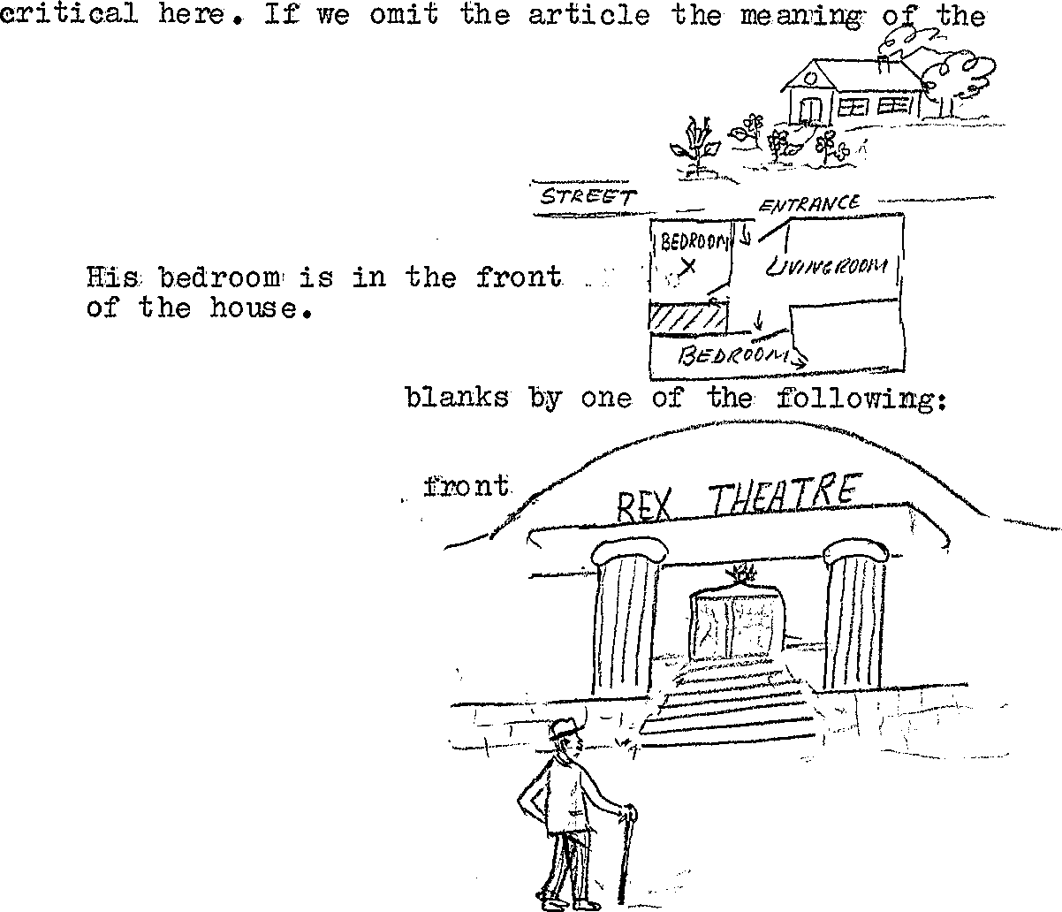

If your answer is:
in the, turn to page 62.
in, turn to page 70
on the, turn to page 67.

Page 67 (from page 66)

Your answer: He is standing on the front of the theater

No. He can not stand on the front of the theater because of the gravity.
It says Rex Theatre" on the front of the theater..

Turn to page 66 and make a reasonable choice.

Page 68 (from page70)

Your answer: The driver couldn’t take any passengers because there was no room in the front of the bus.

Yes, you're right. The driver didn't stop because there was no room inside the bus.
The children are playing in the back of the house.

The use of in the front of and in front of is similar

Now copy the following sentence filling in the blanks according to the given picture. In the case of “back of “ and "front of”, use the if necessary.
- This is a classroom. The students are sitting —— their desks.
- The teacher is standing —— front of the students.
- There is a blackboard —— the wall.
- He has written some sentences —— the blackboard.
- The students have copied these sentences —— their notebooks.
- There is a desk —— front of the room.
- There is a paper basket —— the corner.
- There is a window —— the side of the room.
- —— window, there is a bird.
- There is a small bookshelf —— back of the room.

Turn to page 63 to check your answers.
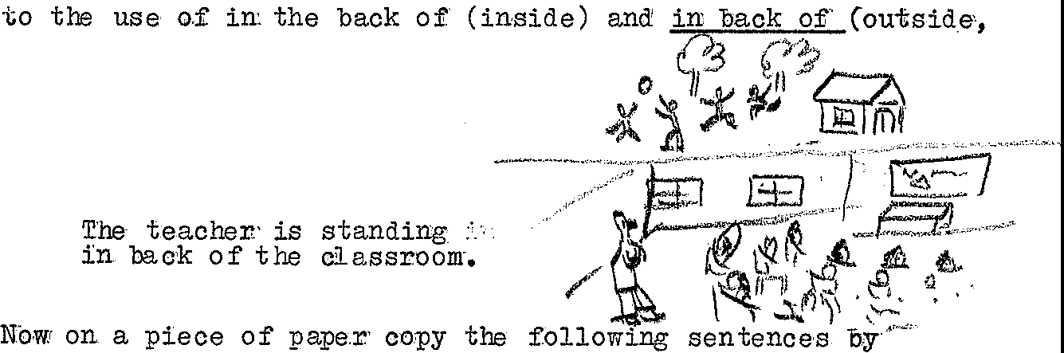

Page 69 (from page 65)

Your answer: He arrived at Istanbul yesterday.

Not quite right. Istanbul is a big city. If we say, “He arrived at Istanbul Airport yesterday", the sentence would be correct.

Turn to page 65 and try to choose the right answer·.
Page 70 (from page 66)

Your answer: He is standing in front of the theater.

Good!, that's right. He is standing outside the theater. So we ca generalize that:
in front : outside of
in the front of: inside of

We can use at instead of in in both of these phrases without making any change in the meaning of the sentence.
in front of : at the front of
in the front of : at the front of

However, in some cases when we use at, the sentence might be ambiguous if there is no word. in the sentence to clarify the meaning:
e.g. "I saw him standing at the front of the theater.” might mean
- He was standing in the front of the theater or
- He was standing in front of the theater.
Now replace “at the front of” in this sentence with the given expressions.
The driver couldn't take any passengers because there was no room at the front of the bus.
If your answer is “in the front of”, turn to page 68.
If your answer is “in front of”, turn to page 73.
Page 71 (from page 65)

Your answer: He arrived on Istanbul yesterday.

No. Wrong. Istanbul is not a city built under the ground.

Now turn to page 65 and try to choose the correct answer.

Page 72 (from page 90)

Your answer:
- I could not move because he was on my way,
- I saw that yellow bus in my way to school,

No. Incorrect.

If someone is occupying a part of his way, that is blocking his way, that means he is in your way. The space he fills in is occupied by someone else.

If you meet someone or something on your way, you simply­ meet him while going. There is space for both of you.

Now turn to page 90 and make another choice.
Page 73 (from page 70)

Your answer: The driver couldn't take any passengers because there was no room in front of the bus.
No. “In front of the bus” means outside the bus. 'l'he passengers sit inside the bus.

Turn to page 70 and choose another alternative.

Page 74 (from page 80)

Your answer: The weather is mild in the Mediterranean coast; therefore, my parents live in Antalya.
The last part of the sentence is correct but we say "on the Mediterranean coast” because the coast is a part of the surface of the earth that follows a certain path.

Now turn to page 82 and choose the correct answer.

Page 75 (from page 64)

The answers to the questions on page 65:The cat is on top of the roof.
- The cat is on top of the roof.
- The bird is on the roof.
- The chair is in the back of the room. (Be sure you used the.)
- The table is in the front of the room. (If you say “in front”, it will be wrong because the table is inside the house, not outside.)
- There is a big garden at the back of the house.
- On the front of the house it says "Holiday Inn".
- The number is. put on the door. (The reason we use on in the last two sentences is that both the number and the sign is on the surface of the house,)
If you have missed any of these and do not know why, first look at the picture on page 64 again and see if you have· located them right. Then. turn to page 78 and try to find out the reasons fbr these answers,

After you are satisfied with the given answers turn to page 65,

Page 76 (from page 82)

Your answer: It is fun to get a sun bath on the shore.

Yes, you're right. Shore is the name given to the surface along the sea.

Beach takes on when it is used in the meaning of 'shore' but if all the
other facilities and buildings are indicated at is used.

According to this definition, fill in the blank in this sen­tence.

I prefer swimming rather than lying —— the beach.

If your answer is on, turn to page 86.
If your answer is at, turn to page 81.

Page 77 ( from page 86)

Your answer: I enjoyed a lot at the party,

Good, Since “'party” is not an object that has volume like a house, you cannot use in. You cannot use on either because there is no visual surface you can think of for “party”. So the best choice is at.
In some cases, deciding which preposition to use becomes very difficult because two of the prepositions can be used in the same format resulting in two different meanings due to preceding nouns.
e,.g,
I read his name on the letter.
I read his ideas in the letter,
First sentence suggests his name written on the surface of the letter. In the second sentence, however, the ideas are hidden in the letter among the sentences.

Now let's try this sentence.

Please give my regards to your family—— your letter.
If your answer is in, turn to page 85.
If your answer is on, turn to page 89.

Page 78 (from page 63)

Now, let's review the use of these prepositions again.
In suggests:
- inside: He is in the theater rehearsing..
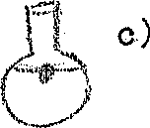
- area bounded or surrounded: He is in the park. He is waiting in the shade.
- closed place that has volume: The cork is on top of the water in the bottle.
On suggests:
- a flat. surface: The stone is on the bottom of the bottle,
- along the line: His house is on the bus route.
At suggests:
- a. a definite but may not be the exact location: I saw him at the station. (Station is a definite place but we do not know the exact location at the station. May be in front of the ticket window, or in the baggage room, or in the waiting room, or in front of the station
- a definite place but there is no reason to use on or in. The seed is at the bottom of the bottle.
- a specific point along a line: He lives at 45 4th Street. Water boils at 100 degrees centigrade .

Now turn to page 64.

Page 79 (from page 98)

Your answer: He was in trouble. To keep his problem in secret, he spoke to me in a whisper .

Yes, you’re right. In the first case, the situation he is in is expressed, in the second case, the situation in which his problem has to be kept is indicated, and in the last case the situation he talked.in is expressed.

Now, let’s try this one.
Do you see the nice carpet——the floor?
If your answer is at, turn to page 92.
If your answer is in, turn to page 93.
If your answer is on, turn to page 96.

Page 80 (from page 65)

Your answer: He arrived in Istanbul yesterday.

Yes, you 're right. With the names of the big cities we use in when we indicate the location of an object or a person. Since the same rules exist for the verb “arrive” the preposition in remains the same.
However, we say, "He arrived at his house." because “house” is the definite point which indicates his destination.

Sometimes the use of on and in is confused in their indication of place. We say “on the west coast” but "in Istanbul". The reason for this is when we say ” on the west coast”, we are thinking of an area which is a part of the earth's surface. Besides that the coast has no boundary as in the city. The city has a boundary like a park or a garden, The boundary in a city is not visual as it is in a park or a garden but it is political.

Now fill in the blank in this sentence.
The weather is mild—— the Mediterranean coast; therefore, my parents live —— Antalya.

If your answer is on, in, turn to page 82.
If your answer is in, turn to page 74.

Page 81 (from page 76)

Your answer: I prefer swimming rather than lying at the beach.

No, I’m afraid not, because you can not lie anywhere you like at the beach except the shore.

Now turn to page 76 and choose another alternative.

Page 82 (from page 80)

Your answer: The weather is mild on the Mediterranean coast; therefore, my parents live in Antalya.

Yes, you’re right. The Mediterranean coast. has no boundary, it even surpasses the boundary of Turkey. Therefore, we consider it as a part of the surface of the earth.You can also think of it as a line following a particular path like a street.

Antalya, on the other hand, is closed and bounded so that it can keep its residents.

In relation to the coast, let's guess which preposition we are going to use in this sentence by looking at the picture below.

shore' ,:
Marmara Sea .’::::’::.....: ·: ·
:’:’:’:’:’:’:’:’)
(The water)
——————————
Marmara coast (the earth)
-+-+-+-+-+-+-+
It is fun to get a sunbath ___the shore.

If your answer is on, turn to page 76.
If your answer is in, turn to page 84.

Page 83 ( from page 86)

Your answer: l enjoyed myself very much in the party.

No, because a party is not a place having volume, so you can not get into it.

Turn to page 86 and try another choice.

Page 84 (from page 82)

Your answer: It is fun to sunbath inside the shore.

No. There is no way of getting a sunbath inside the shore.

Turn to page 82 and make another choice,

Page 85 (from page 77)

Your answer: Please give my regards to your family in your letter.

Yes, it is right. The idea of sending regards is expressed in the letter through the use of words or sentences.

Keeping the same rule in mind fill in the blank in this sentence.

I have seen your name —— the list.

If your answer is on, turn to page 90.
If your answer is in, turn to page 88.o

Page 86 (from page 76)

Your answer: I prefer swimming rather than lying on the beach.

Yes, you are right. The verb 'lie' also indicates a flat surface. We can use at if we say, "We spent the whole day at the beach today.” Logically, you are not expected to spend the whole day on the sand.

In the use of in, on, ,at, if you are not sure of the correct preposition, think of the possibilities of in and on first. If the following noun has a volume and if the semantic interpretation is logical, in fits that slot perfectly.
If the noun suggests a surface, use on. When you find that on and in are not appropriate in that sentence, the best thing would be to use at.

Try this sentence now.

I enjoyed myself very much——the party.

If your answer is at, turn to page 77.
If your answer is in, turn to page 83
If your answer is on, turn to page 94.

Page 87 (from page 95)

Your answer: Why are you at a hurry?

No. We are asking the reason for his being in such a situation.

Turn to page 87 and make another choice.

Page 88 (from page 85)

Your answer: I have seen your name in the list.

No.’List’ here suggests a piece of paper on the surface of which you list the names of items or people.

Now turn to page 85 and choose another alternative.

Page 89 (from page 77)

Your answer: Please give my regards to your family on your letter.

No, it is wrong. You do not give regards on the surface of a letter. Instead, you write one or two sentences in which regards are expressed.

Now turn to page 77 and make the alternative choice,
Page. 90 (from page 85)

Your answer: I have seen your name on the list.

Yes, right. The name is visually seen on the list,

Observe these two sentences first; then fill in the blanks in the second pair.
- I met him on Sakarya Street.
- I was driving home when I. saw the children playing in the street. I had to slow down so that I could stop anytime if the children would not make way for me.

- I could not move because he was —— my way.
- I saw that yellow bus —— my way to school.

If your answer is :
On for Sentence 1,
In for Sentence 2, turn to page 72.

If your answer is:
In for Sentence 1,
On for Sentence 2, turn to page 95.
Page 91 (from page 98

Your answer: He was in trouble; to keep his problem at secret, he spoke to me at a whisper.

You have started the first part right, but the rest of the sentence is wrong. He wanted to keep his problem in a situation. so that no one: would know about it. Therefore, his voice came out in a way that the others could not hear him.

Now turn to page 98 and read the sentence again, using the right prepositions.
Page 92 (from page 79)

Your answer: Do you see the nice carpet at the floor,

No, it is not right, Floor has two dimensions like a wall.

Turn to page 79 and make a correct choice.

Page 93 (from page 79)

Your answer: Do you see the nice carpet in the floor?

No. I do not see any way of hiding the carpet in the floor. Besides, the verb “see” indicates that the carpet is someplace where it can be seen.

Turn to page 79 and make another choice.

Page 94 (from page 86)

Your answer·: I enjoyed myself very much on the party..

No,. Can you think of a party having a flat surface like a golf course?

Turn to page 86 and make another logical choice.

Page 95 (from page 90)

Your answer:
- I could not move because he was in my way,
- I saw that yellow bus on my way to school,

Ye.s, you're right. If you cannot move it means that someone is blocking your way. “On my way to” simply means while going,

In expressing the situation a person is in, we use in,
This type of sentence usually answers the question HOW?
e.g.
- How is he?
- He is in trouble

- How are we going to prepare this?
- We'll prepare it in secret,

- How did he speak?
- He spoke in a whisper.

At is also used in sentences to answer the question HOW.
e.g.
- How did the car go?
- The car went at ful speed.
A. How did he fight?
B. At his best.

At expresses a definite situation along other degrees.

Now fill in the blank for this sentence.
Why are you—— a hurry?
If your answer is at, turn to page 87.
If your answer is in, turn to page 98.
Page 96 (from- page 79)

Your answer: Do you see the nice carpet on the floor?

Yes, you're right because the carpet covers the surface of the floor.

Now turn to page 99 and fill in the blanks with at, on, or in.

Page 97 (from page 99)

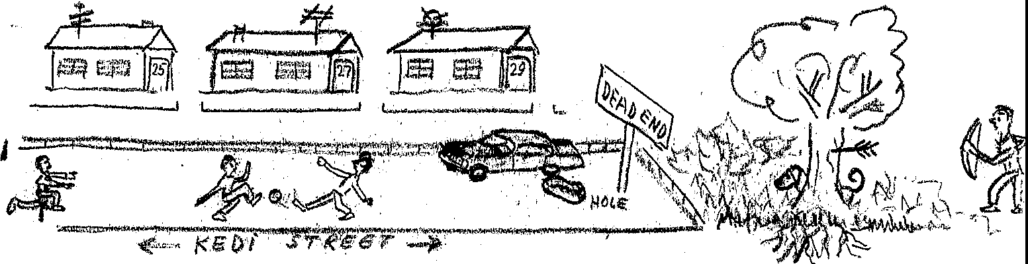

Copy the paragraphs inserting the prepositions in, on and at,
Ahmet and his family stay — Izmir, — the west Coast of Turkey. They live —— 29 Kedi Street. There are only three houses — this street. — top of these houses there are TV antennas. The numbers of the houses are — the doors. Ahmet 's house is — the end of the street. His father’s car is parked— the end of the street, right — front of their house. When Ahmet gets — the car, he sits— the back of the car.

Ahmet is playing football with his friends— the street— the sun. They are playing — back of the street because they are afraid of hitting the ball — the hole, — front of the car. — the very end of the street, there is a sign. — the sign, it says, “Dead street”. — the right side of the street, there is a big pool — the park. When the weather is good, they play — grass or swim — in the pool.

There is a dog — back of the tree. He is standing — the shade. In spring they see the leaves growing — the trees. However, we cannot see the roots of the trees — the ground. A stranger has arrived — the park, he has shot an arrow — the tree. Now the arrow is — the tree. (Give your paper to the teacher to be corrected.)

Page 98 (from page 95)

Your answer: Why are you in a hurry?

Yers, you’re right. We are asking why he is in such a situation.
There are no levels of the situation being expressed

Now let’s try this one.

He was — trouble; to keep his problem — secret, he spoke to me — whisper.

If your answers are in this sequence: in, at, at, turn to page 91.
If your answers are in this sequence: in, in, in, turn to page 79.

Page 99 (from page 96)

Fill in the blanks with in, on, or at, as you copy the sentences.

- Will he be — meeting tonight?
- I have twenty students — my class — in this room.
- The war was fought — land, — sea and — the air.
- The car went — full speed.
- What news is there — the newspaper this morning?
- We live — the north side of the river.
- This train stops — all stations.
- This village is — your way to İstanbul from Ankara.
- There are shops — both sides of the street.
- He is — work for a new book.
- To be — debt is to be — danger.
- We arrived — his house the next day.
- Munich is — Germany.
- He had a new — his head and a new coat — his back.
- The town is — the west coast of the river.

Give your paper to the teacher to be corrected.

Now turn to page 97 and fill in the blanks according to the given picture.

